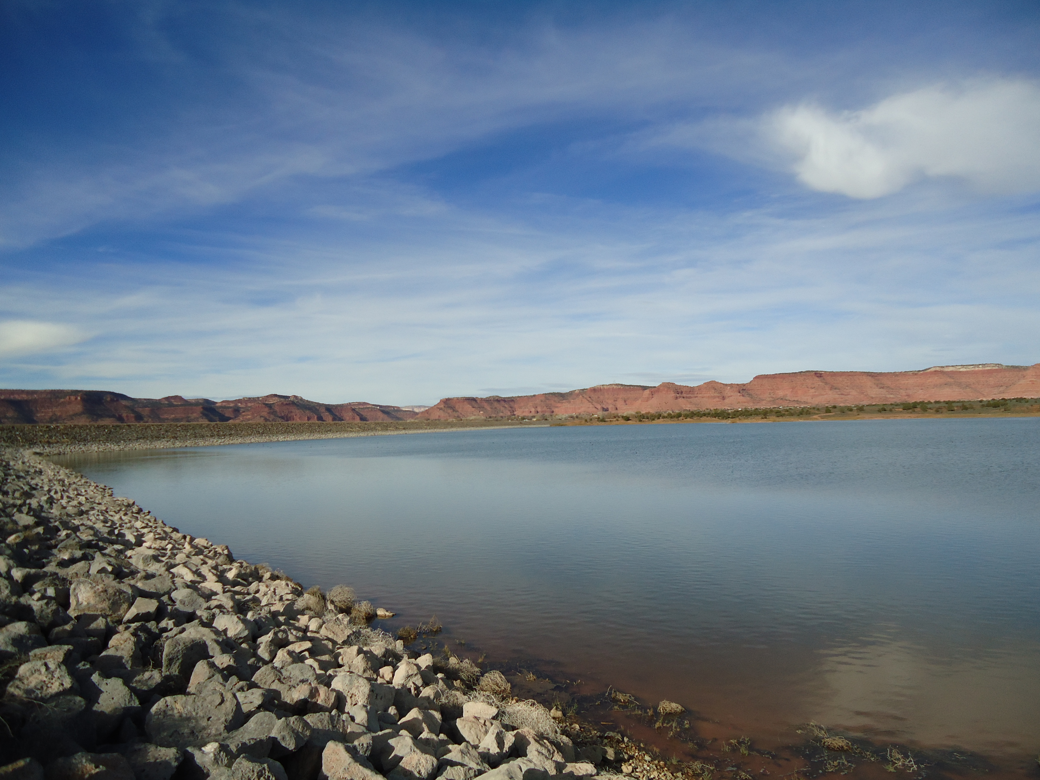

##### **Zion View**

275 new services were completed during the project, of which 160 were financed.

Kcwcd owns 10,000 acre ft. of water rights in Lake Powell.

The 4,228 acre-feet reservoir will increase crop production. Utah is the 2nd driest state.

##### **Powell Pipeline**

##### **Jackson flat**

Recent/Upcoming Projects

Board Meetings are held every 2nd Thursday of the month. Meetings during November through March begin at 6:00 p.m., while other months of the year begin at 7:00 p.m. There is no meeting in February. All meetings are held in the county commission chambers in Kanab, Utah. Important topics are discussed that affect the public and their water needs. Agendas are posted on the district website. If you have an issue and want to be added to the agenda, please contact the office (435-644-3997) by the end of the month preceding the board meeting.

Board Meetings!

It’s that time of the season to make sure your water lines are protected from winter weather. The freezing level (especially on Cedar Mountain) is relatively deep and pipes will be less likely to break if they are buried at the six ft. level. Property owners are responsible for the water line that extends from the meter barrel to (and into) your structures, including any spigots or yard valves. Remember to wrap them securely to keep the lines from breaking during the harshest of winter weather.

As a reminder, snow removal and access to your meter barrel is the customer’s responsibility. Should you need KCWCD service personnel to check your meter, the snow must be removed first. If the area around your meter is not cleared, we cannot respond.

Please be sure to monitor your winter bills for evidence of leakage. If you get an unusually high reading during the winter, go to your property and check your water lines. Damaged water lines and broken indoor pipes can cause considerable damage to your property. KCWCD is not responsible for property damage due to water leaks. **Last thing is to always remember to turn your customer valve off before leaving your property.**

### Time to Winterize

Kane County Water Conservancy District

KCWCD PIPELINE

the

winter 2014

**Net position or commonly referred to as equity, may serve over time as a useful indicator of an institution’s financial position. KCWCD’s debt to equity relationship this past year was a 52/48 ratio.**

PAYMENT OPTIONS

Save a dollar on your bill every month by signing up for our automatic payment service. Just contact us through phone or email to set up APS and start saving.

Pay your bill online at kcwcd.com under the “pay online” link.

Pay over phone at 866-917-7368 (there’s a $2.99 convenience fee)

**GET ON OUR WEBSITE**

**AT**

**kcwcd.com**

* When doing laundry, match the water level with the size of the load.
* Turn the water off while brushing your teeth.
* Be a detective! Check all hoses, connectors and faucets regularly for leaks.
* Soak pots and pans instead of letting the water run while you scrape them clean.
* While you wait for hot water, collect the running water and use it to water plants.
* Avoid recreational water toys that require a constant flow of water.
* Plant in the spring and fall, when watering requirements are lower.
* Use a rain barrel to harvest rainwater from gutters for watering gardens and landscapes.
* Use a broom instead of a hose to clean patios, sidewalks and driveways.

**Take a minute and look over some other ideas we can use to start saving water now.**

Wateruseitwisely.com/100-ways-to-conserve/?view=list

Lets start conserving water!

# Follow us now on Twitter

# @kanecountywater