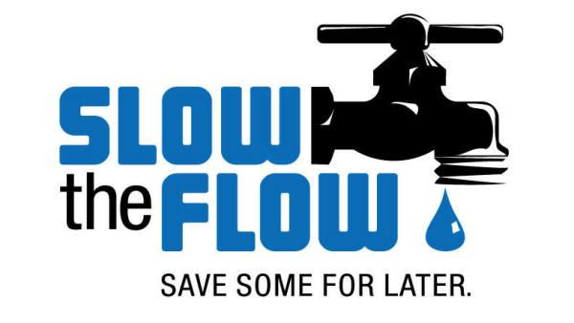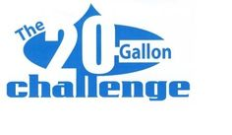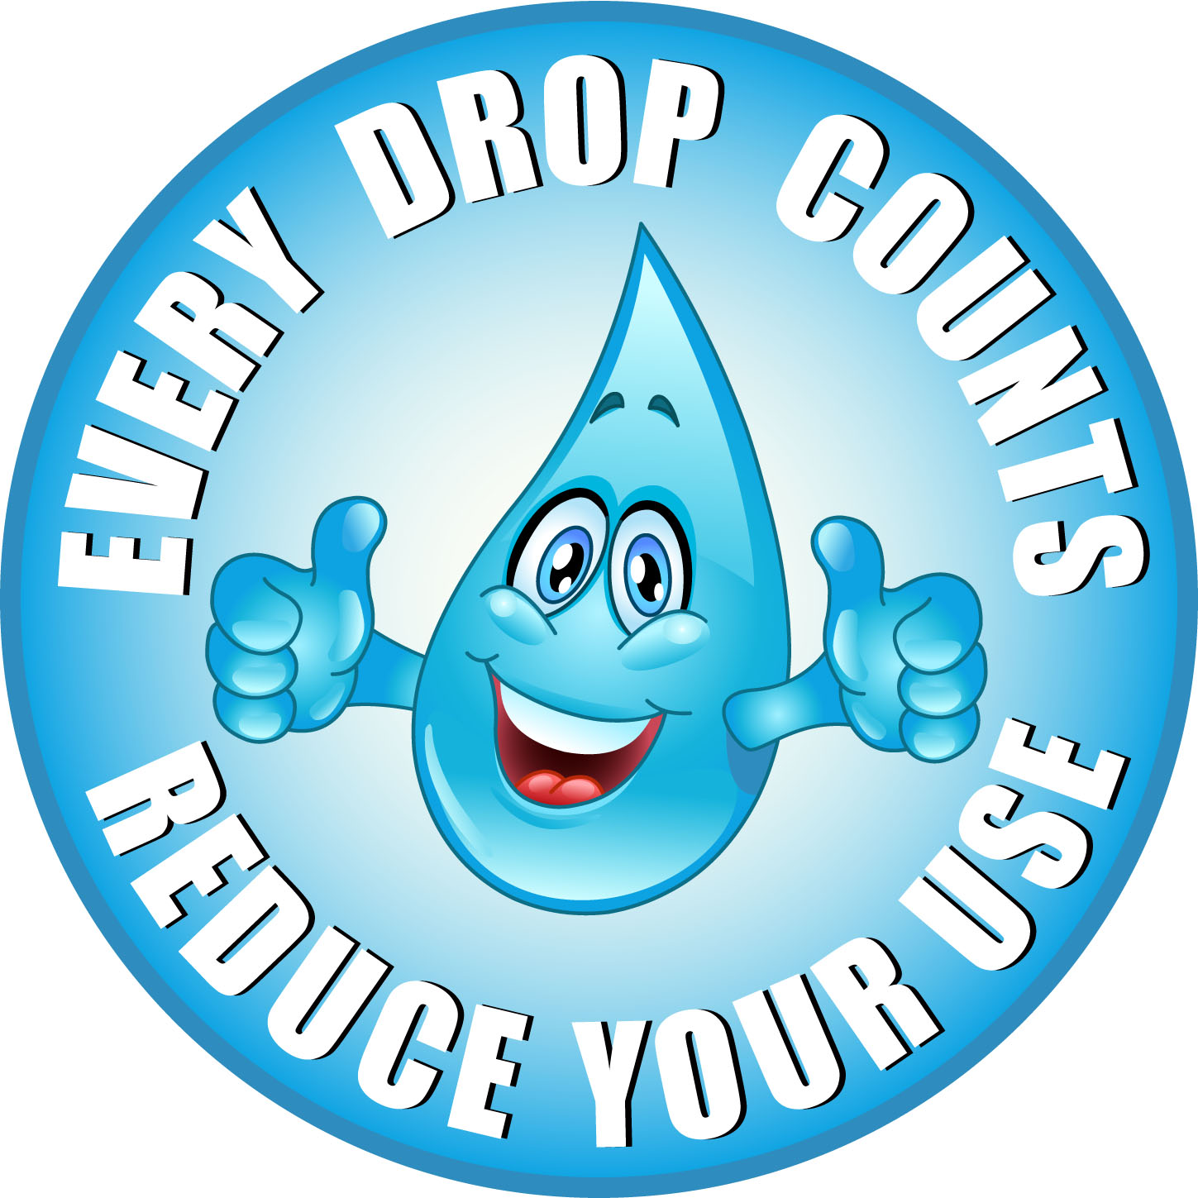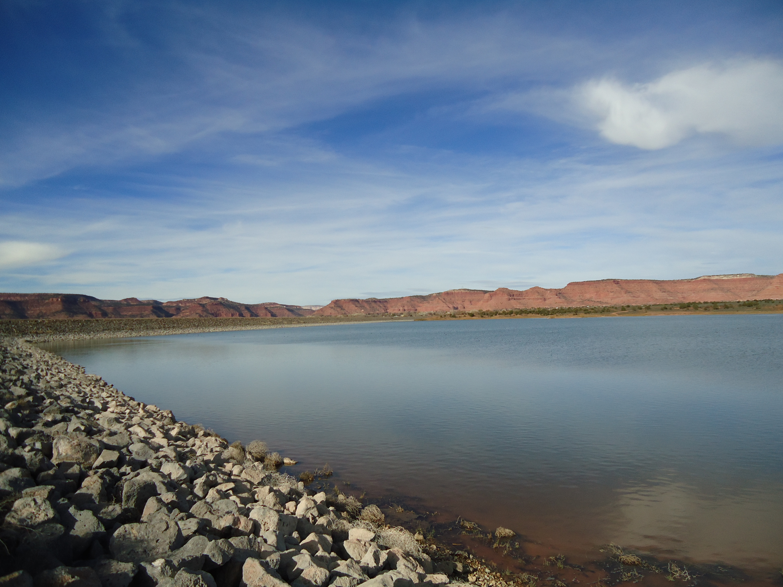

Kane County Water Conservancy District

Go to: <http://wildlife.utah.gov/fishing-in-utah.html> for regulations on fishing.

The Governor of Utah Gary Herbert has come up with a new water initiative and goal to reduce per capita water use by 25% by the year 2025. We need to challenge ourselves in reducing our indoor and outdoor water consumption. The 20-Gallon Challenge will educate people in Kane County on how they can contribute to the governor’s goal by the year 2025. Saving water is a lot easier than you may think. All it takes is a few small changes to your daily routine and you can make a big difference in your monthly water bill.

* Shorten showers
* Fix leaky faucets/toilets
* Turn water off while brushing teeth
* Wash only full loads of clothes
* Don’t use the toilet as a wastebasket

# 20 Gallon Challenge

After a full summer of visiting your property, there may be leaks in your water system that is causing unusually high water bills. If you suspect that you may have a leak or an issue that is causing you to have a high water reading, give our office a call and we can send out a specialist to assist you. By making sure that all your water is off at the property, we can tell whether you have a leak or not by watching your water meter at the meter barrel. If the meter is spinning, then you can trace your water line back and look for possible clues to where the leak is.

# Water Audits

9/7/15 - labor day

10/12/15 -Columbus

11/11/15 - Veterans

11/26 & 27/15 – Thanksgiving

09/10/15 – 7:00pm

10/08/15 – 7:00pm

11/12/15 – 6:00pm

Held in the Kane Co. Commission Chambers

KCWCD PIPELINE

fall 2015

##### Board Meetings

##### Office Closed

##### Jackson Flat

#### Announcements

### The

Lake Powell Pipeline Project

Household Water Audit

Fall Newsletter

**Randy has worked for KCWCD for 15 years. As the office manager and accountant, he keeps an eye on the District’s finances and is also responsible for maintaining the water systems once they are constructed and operational. He has lived in Kanab for 30 years where he has raised 5 kids. He got his degree from BYU and still enjoys following their sports programs. He keeps busy with his 14 grandkids with 2 more on the way.**

Be a detective! Check all hoses, connectors and faucets for leaks.

Turn the water off while brushing your teeth.

Plant in the spring and fall, when watering requirements are lower.

Randy Brown

Meet the Staff

Find us on Facebook under Kane County Water Conservancy District

At

The Jackson Flat Reservoir was just recently planted with 6,000 Bluegill. The fish planted in the reservoir are all about 6 inches long and will need some time to grow. The reservoir will provide a place for the community and tourists to fish and enjoy the surrounding area.

Comments or Questions

If you have any comments, questions or concerns please contact us and let us know so we can know how to better serve you. Email us directly from our website under the contact KCWCD tab or at www.kcwcd.com

# Follow Us on Twitter

# @KCWCD

## What is new to the website?