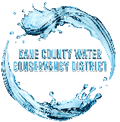
The KCWCD PIpeline
  - kane county water conservancy District
  - 06/18/20
  - Summer Newsletter
Kane County celebrated Kanab City’s 150th birthday on June 13, 2020. KCWCD hosted some of the activities at Jackson Flat Reservoir in Kanab, UT. Kane County brought in Nitro Circus who set up their blob on the beach and launched people into the sky, just to crash down into the water. The County also reserved all kayak and paddleboard rentals from the Adventure Tour Company and allowed the public to enjoy Jackson Flat Reservoir from one of their floating devices. The public enjoyed food that was provided by the food trucks that were present. This made for a full day at the reservoir, enjoying the different activities going on at Jackson Flat Reservoir. The event was a success and was estimated that approximately 1,000 people showed up throughout the day.
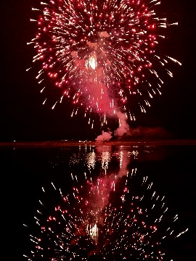
KCWCD hosted the 24th of July fireworks that shot out over the water at Jackson Flat Reservoir in 2019. KCWCD will host the fireworks again in 2020. The show will start approximately at 9:00 PM. All are welcome to comemorate with us!

Office Hours 9:00 AM – 5:00 PM (Monday – Friday) Office Closure: 07/03/20 Independence Day 07/24/20 Pioneer Day 09/07/20 Labor Day

KCWCD continued to operate in the midst of the covid-19 shutdown as water utility is considered an essential business. However, the office building closed its doors for some time to flatten the curve and to not jeopordize the health of employees and customers alike. Since that time, KCWCD has decided to re-open it’s doors to the public and wants to encourage safe practices moving forward. This means: not coming into the office if one is feeling sick in any way, washing hands before and after entering the building, take advantage of the hand sanitizer provided at the front desk, use a mask while inside the building, practice social distancing by maintaining a distance of 6 feet between yourself and others around you, consider wearing latex gloves, etc. All are welcome to come into the office to pay bills or any other matter but consider calling in or sending an email to the address provided below before coming into the office in person. Bills can be paid in a number of different ways which include calling into the office at number provided below, signing up for automated withdrawel, bill pay with your bank, mailing a bill through the mail and paying yourself online at https://kcwcd.com/pay-online/ . Covid-19 is primarily transmitted person-to-person so if we can make some minor adjustments to the way we do things including paying our bills, we will make a big difference in slowing down the spread of the virus. KCWCD would like to thank all in advance for being responsible and taking this health risk seriously.  www.kcwcd.com 435-644-3997 kanecowater@gmail.com |  | WATER CONSERVATION TIPS Be aware! Listen for drips & leaks around house Check outdoor faucets, pipes and hoses for leaks Take shorter showers, try for under 5 minutes Turn faucet off while shaving, brushing teeth, etc. Teach children water conservation tips Use mulch around plants and trees Avoid watering on windy days Only wash full loads of laundry Install drip irrigation system  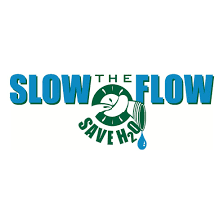  SUMMER MONTHS  The months of June, July, August and September are the months that water users generally use more water at their properties. We should always practice water conservation measures but especially during these hot summer months. Educating yourself on water conservation efforts is the first step in the process. Visit our website at https://kcwcd.com/conservation/ and commit yourself to applying just a few water conservation tips. With time, you’ll save not only our precious water resource, but also your own money!

